
NAME; WENDY KING’ORI
REG NO; BSCCS/2024/73317
COURSE;BACHELOR OF SCIENCE IN COMPUTER SCIENCE
UNIT CODE; BIT3208
UNIT NAME;ADVANCED WEB DESIGN AND DEVELOPMENT
LECTURER;MR NYORO MICHEAL
YEAR;3.2

PROJECT;SUPERMARKET INVENTORY
SELECTED TECH;JAVA+MYSQL
Github link; https://github.com/wendykingori61/nchi-supermarket
Table of Contents
WEEK 1; XAMPP LOCAL ENVIRONMENT SETUP 1
WEEK 2; UI/UX AND DESIGN FOUNDATIONS 4
WEEK 3;FRONTEND SCRIPTING AND BACKEND PROGRAMMING FOUNDATIONS 7
WEEK 4: DYNAMIC BACKEND FORM PROCESSING & SYSTEM AUTHENTICATION 9
WEEK 5: DATABASE COMPLETION AND DYNAMIC CRUD SYSTEM LAYER INTEGRATION 13

WEEK 1; XAMPP LOCAL ENVIRONMENT SETUP

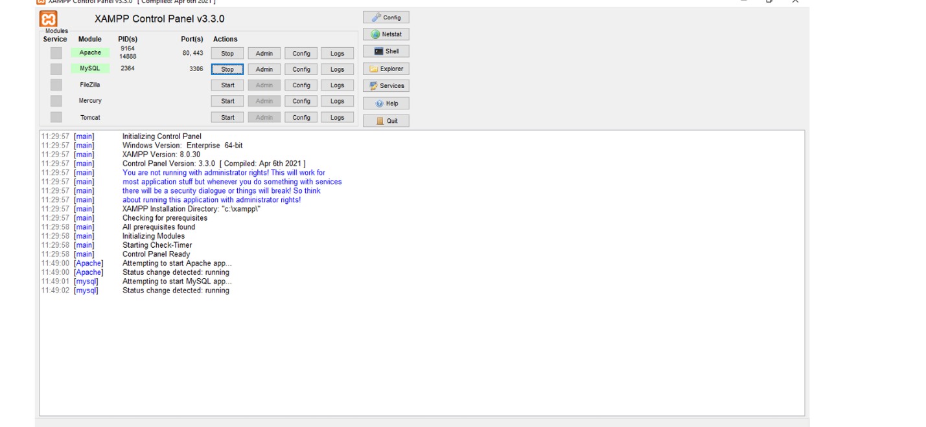
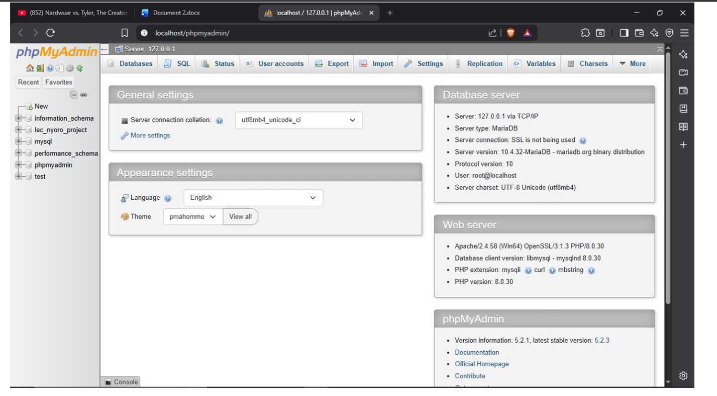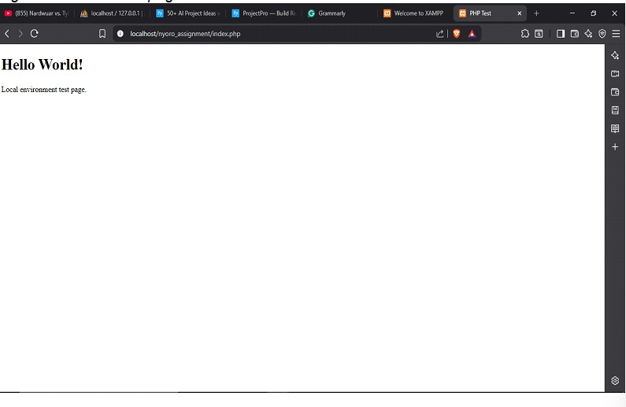
REFLECTION
Mastered local server architecture deployment by configuring XAMPP (Apache and MySQL). Learned the difference between client-side and server side execution and organized a modular, professional project directory structure for proper software development workflow.

WEEK 2; UI/UX AND DESIGN FOUNDATIONS
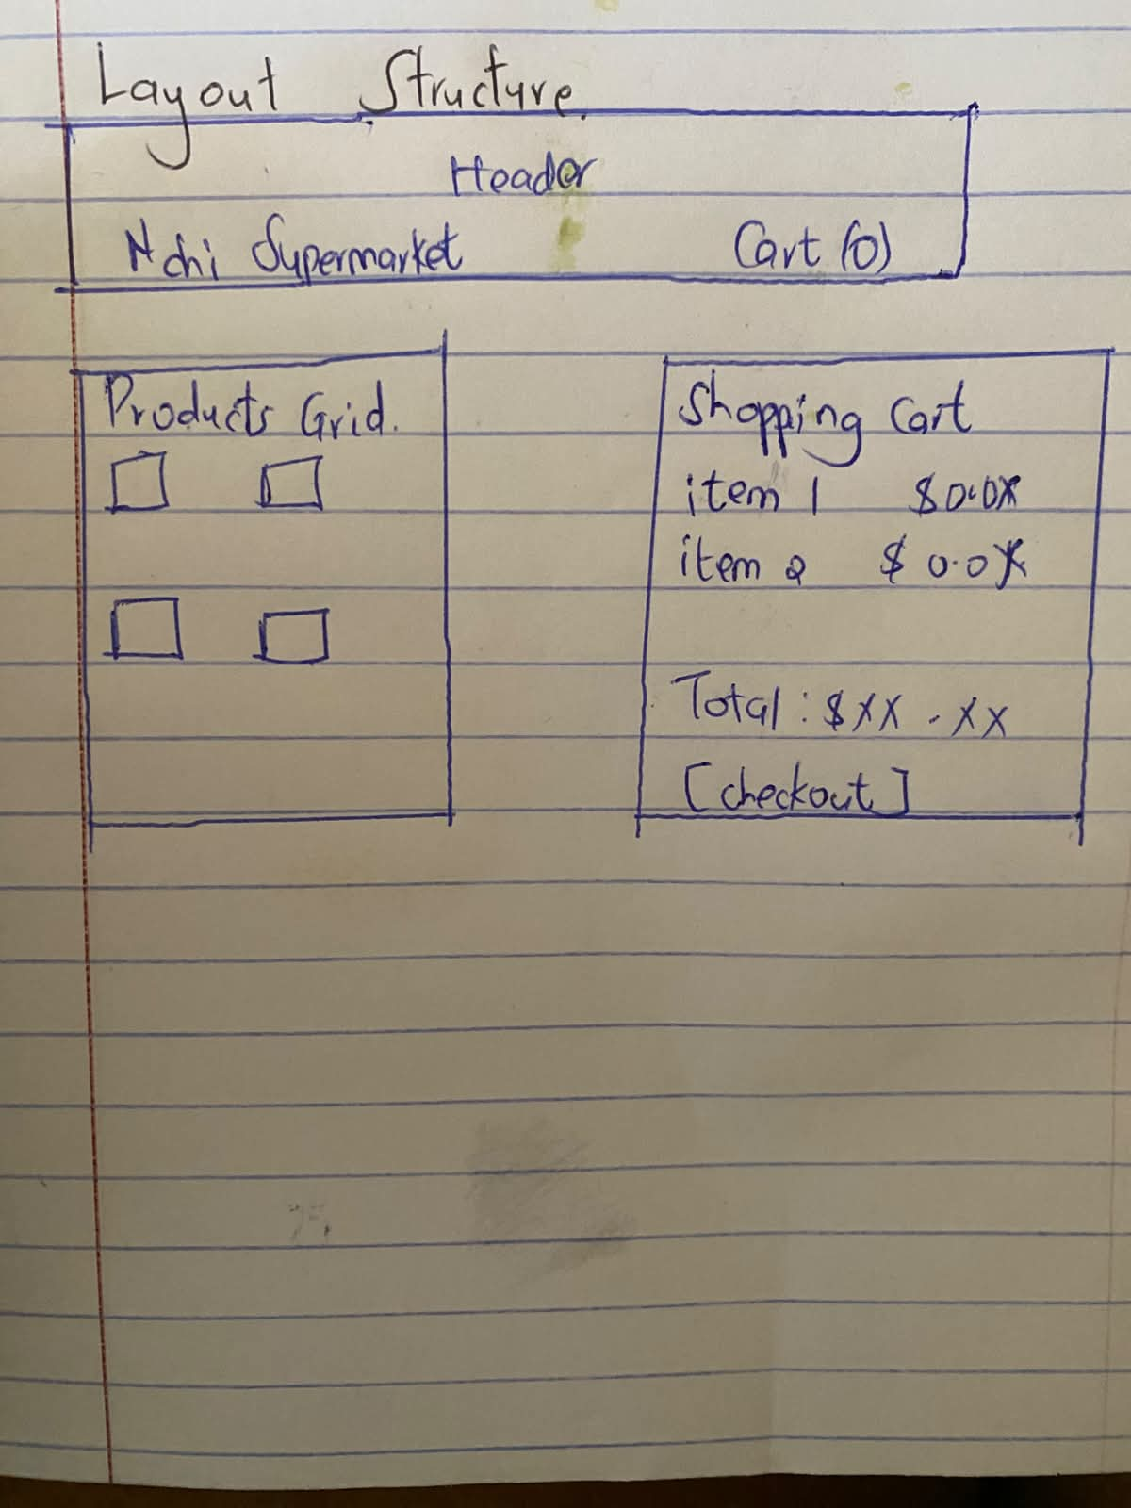
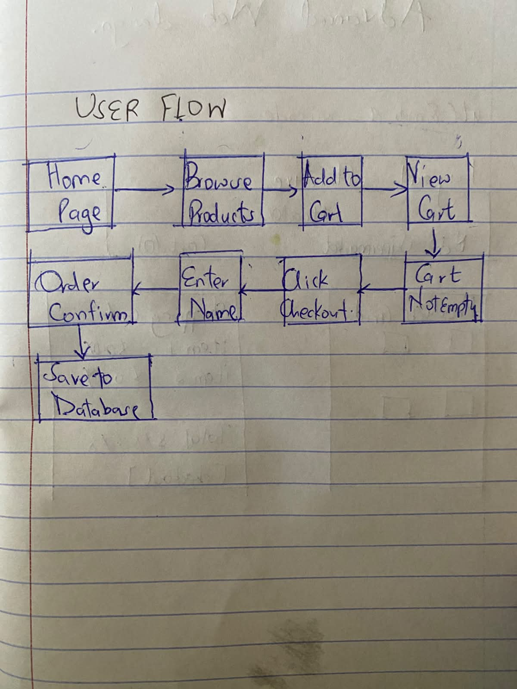
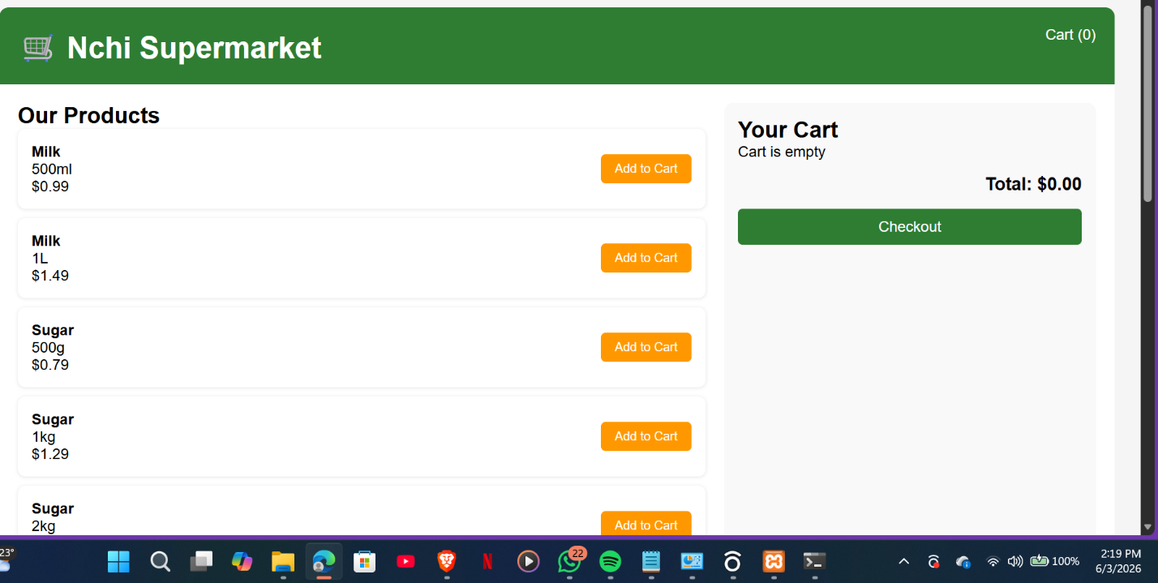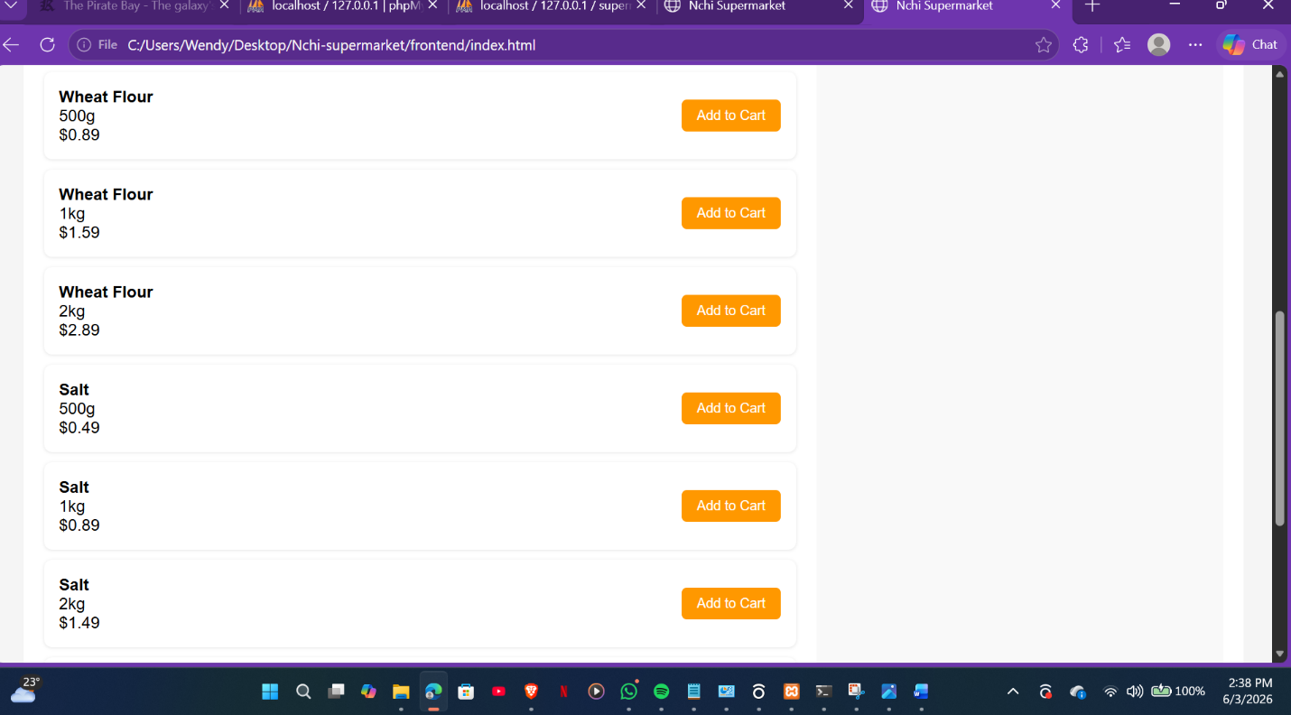

REVIEW
Nchi Supermarket offers a clean, intuitive interface with a green-themed design that feels fresh and trustworthy. The two-column layout keeps products visible while the cart stays accessible on the right, and hover effects on product cards provide satisfying visual feedback. All actions trigger clear success or error messages, making the shopping experience smooth and user-friendly.

WEEK 3;FRONTEND SCRIPTING AND BACKEND PROGRAMMING FOUNDATIONS
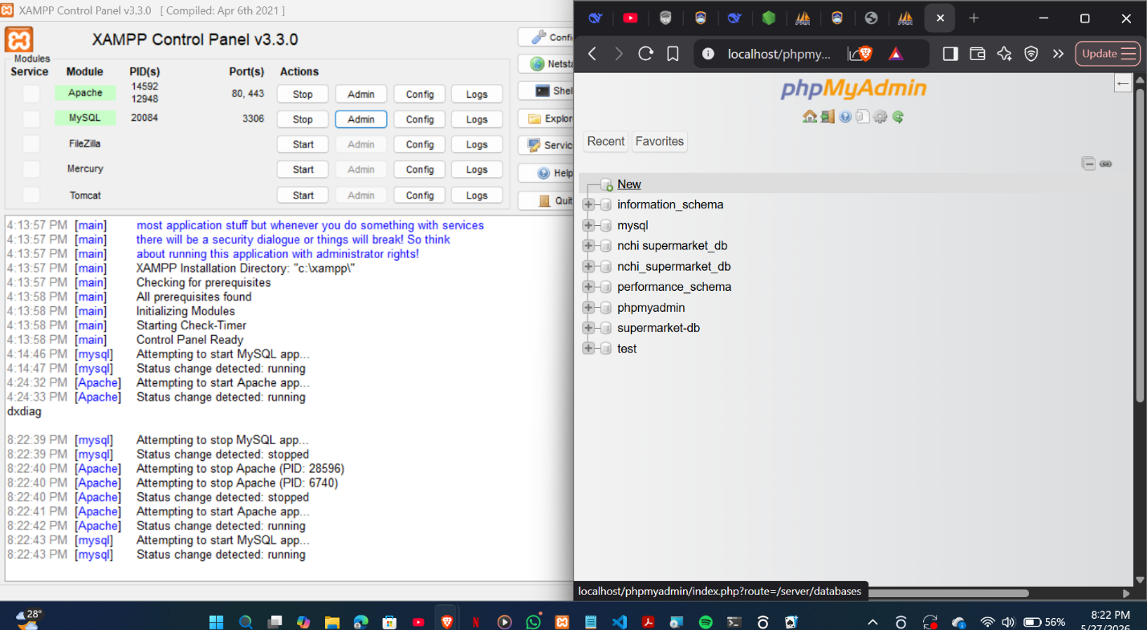
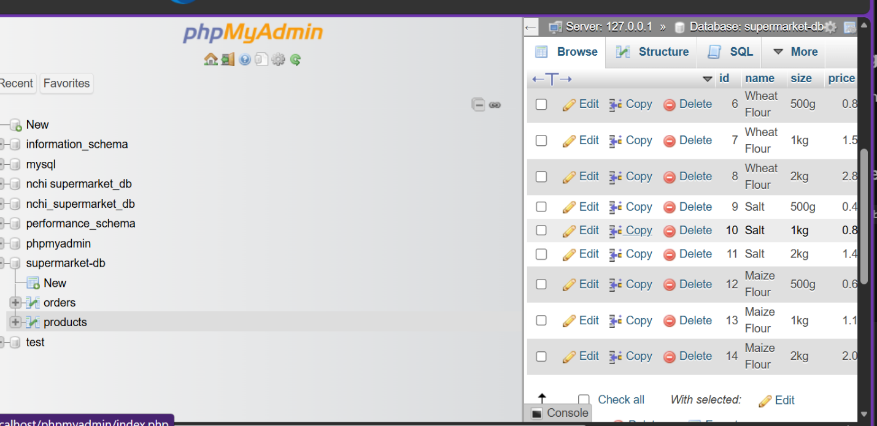
REVIEW
Nchi Supermarket is a full-stack e-commerce website that sells milk, sugar, wheat flour, salt, and maize flour in multiple sizes. It uses Node.js + Express on the backend, MySQL for the database (managed via phpMyAdmin), and HTML/CSS/JavaScript on the frontend with localStorage for the cart (no cookies). The website connects to a database via a connection string, displays all products dynamically, and saves customer orders permanently.

WEEK 4: DYNAMIC BACKEND FORM PROCESSING & SYSTEM AUTHENTICATION
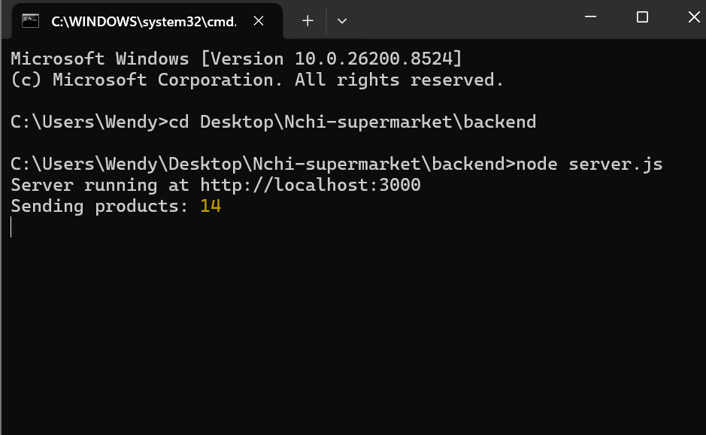

Db.js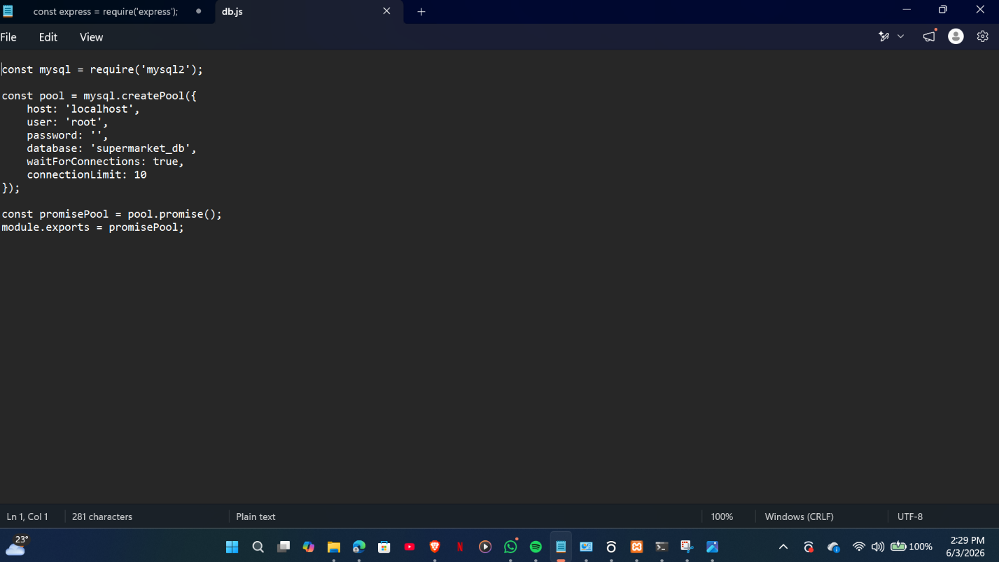

Server.js
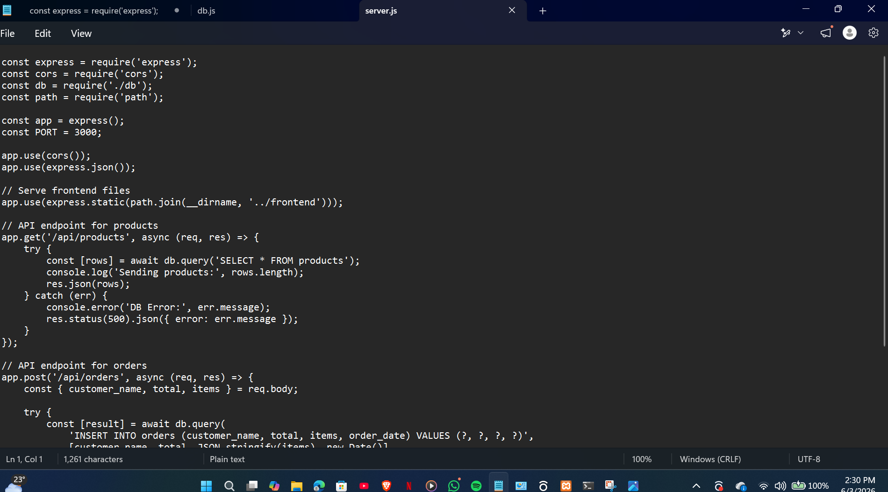

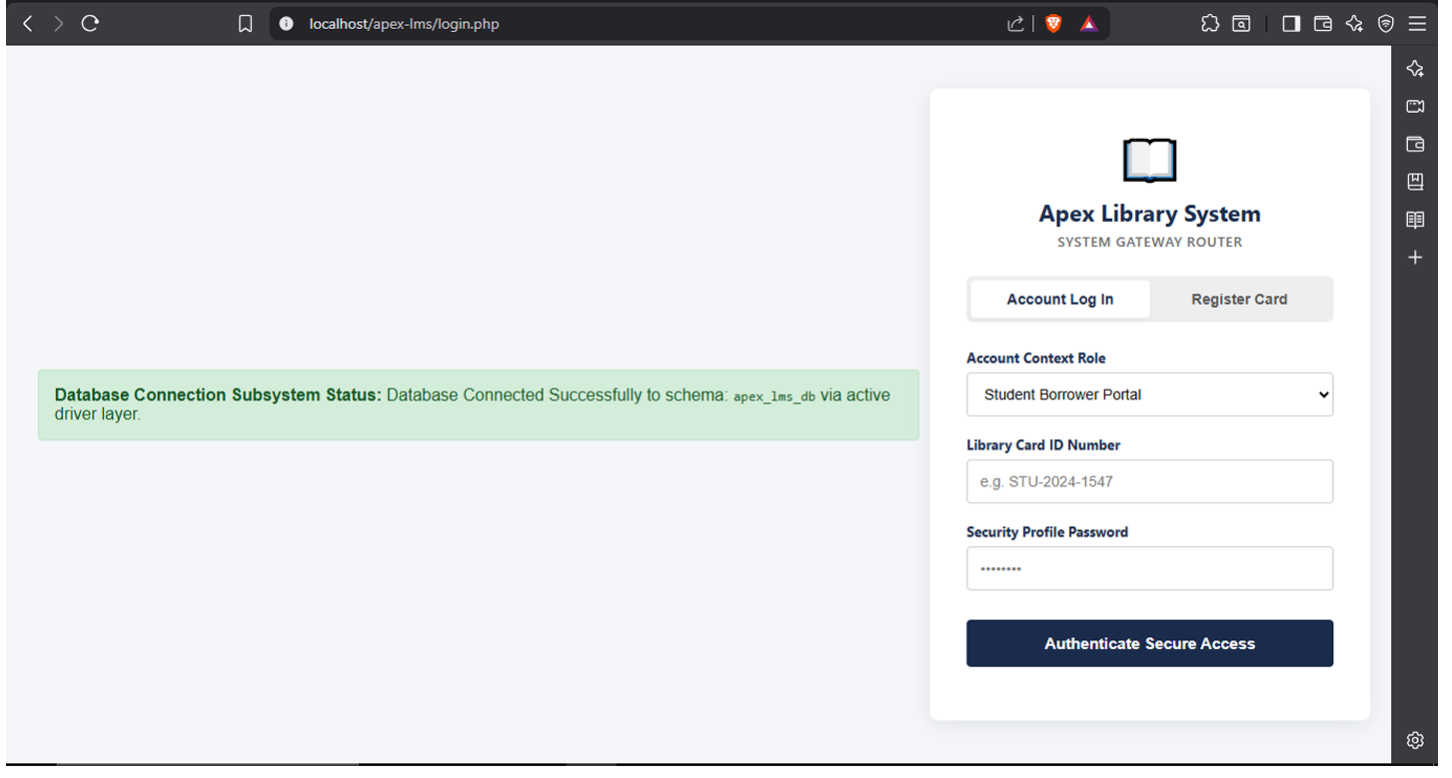
REVIEW
Learned the full HTTP request-response cycle by integrating HTML forms with backend processing. Implemented secure data handling via the POST method, introduced user authentication pipelines using session tracking ($_SESSION), and created a defensive middleware gatekeeper file

WEEK 5: DATABASE COMPLETION AND DYNAMIC CRUD SYSTEM LAYER INTEGRATION


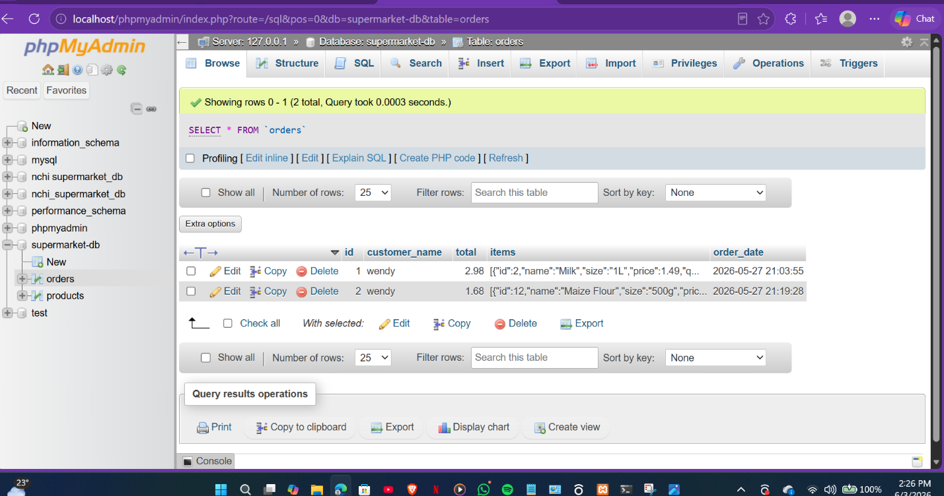

REVIEW
Implemented full backend data-driven integration. Constructed relational MySQL schemas with foreign key constraints, mastered full CRUD mechanics (Create, Read, Update, Delete) to dynamically add, display, and purge database assets, and effectively debugged system runtime errors like SQLSTATE base table exceptions.

